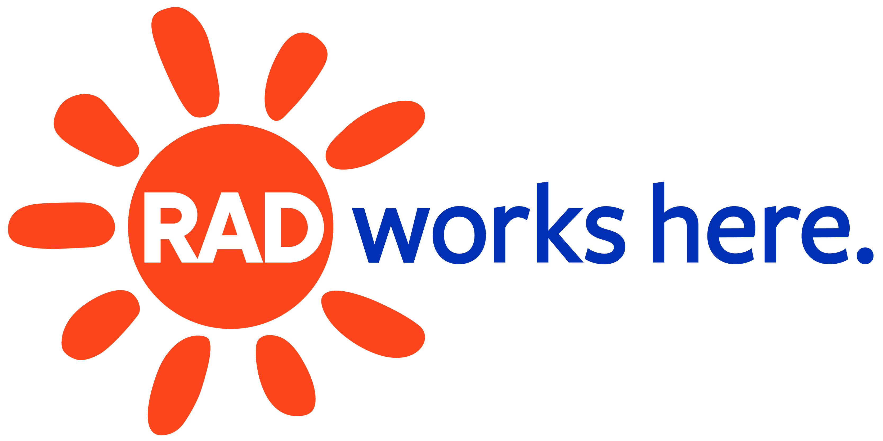
ALLEGHENY REGIONAL ASSET DISTRICT

Capital Project Requests – 2024 Application
Organization:
Project Name:
Amount Requested from RAD: $
% of Project Funds Requested from RAD: $
Urgent, shovel-ready capital maintenance, major equipment purchases and major repairs to existing facilities are eligible as are projects and equipment designed to make facilities and programming more accessible. Useful life of improvements should be reasonably consistent with applicants' ownership or lease situation. Financial support from other sources will be taken into consideration during evaluation. Grants awarded will have two years for drawdown, beginning on January 1st of the award year. Planning and feasibility studies are not eligible. If you have requested funding for capital projects you will need to provide additional information on the project or projects. Please answer the following questions and upload your document and supplemental materials to your application.
- Provide a detailed description of the project(s). (limit to 2,500 characters)
- Provide a breakdown of the project costs, including the total cost. (limit to 2,000 characters)
- List all other sources of funding (including public funding such as RACP or CITF) that will be applied to this particular project. Include each source, the amount, and status (secured or pending).
- Do you have at least two professional estimates for this project? If yes, you must attach the estimates with your application. If no, you are not eligible for capital project funding at this time.
☐ Yes
☐ No
- What is the completion date of the project? (limit to 250 characters)
- Do you own the space where this project will be completed?
☐ Yes
☐ No
If no, please answer the following. Who is the lessor? What is the term length? Are there options for extension? If so, what are they? (limit to 1,000 characters)
- Does this project address a safety concern? If yes, please explain. (limit to 1,000 characters)
☐ Yes
☐ No
- Does this project address a regulatory or compliance issue? If yes, please describe the relevant codes, regulations, statutes, etc. (limit to 1,000 characters)
☐ Yes
☐ No
- Does this project address an accessibility issue? If yes, please explain. (limit to 1,000 characters)
☐ Yes
☐ No
- Is your project sustainable upon completion? Do you have capital reserves to maintain? (limit to 1,000 characters)
- What is the impact to revenue and / or expenses if this project is not completed? Please explain. (limit to 1,000 characters)
- If applicable, please provide any details if the project is considered public art or has a public design component. (limit to 1,000 characters)
Statement of Assurances:
By selecting Yes below and submitting this capital project request, you agree that your organization will afford opportunities to Minority Business Enterprise (MBE), Woman Business Enterprise (WBE), and/or Disadvantaged Business Enterprise (DBE) firms.
☐ Yes
☐ No

